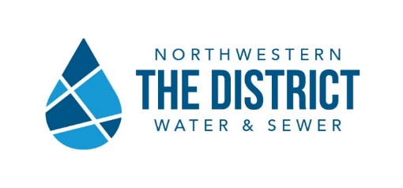

12560 Middleton Pike, P.O. Box 348, Bowling Green, OH 43402 - 877-354-9090
nwwsd.org
Wednesday, December 9, 2020
FOR IMMEDIATE RELEASE

Sugar Ridge | Mercer Road Sewer Project
Public Meeting Teleconference Information
BOWLING GREEN, Ohio, The Northwestern Water and Sewer District will host a public meeting for the Sugar Ridge | Mercer Road Sewer Project scheduled for Wednesday, December 16, at 6 p.m. This meeting will take place via teleconference call.
The Sugar Ridge | Mercer Road Sewer project will impact approximately 57 homes along Sugar Ridge Road and Mercer Road in Middleton and Center Townships. The meeting is for residents within and just outside of the proposed project area and will cover topics such as the Ohio EPA mandate for sewers, the design for the sanitary sewer line project, the updated timeline for the project, and how it impacts your property. Information regarding the project can be found at www.nwwsd.org/sugarridge.
Members of the public in and near the project area may join the meeting by following these instructions:
Webinar: On Wednesday, December 16, at 6 p.m., join the webinar by clicking/entering this link into your web browser:
https://us02web.zoom.us/j/84400587472
Phone only: On Wednesday, December 16, 2020, at 6:00 p.m., use your phone to dial:
1-312-626-6799. When prompted, use Meeting ID: 84400587472, followed by #.
You may be prompted to enter a “Participant ID”. If so, press # to skip.
Comments: Residents can submit comments during the meeting by using the chat feature in the zoom program during the presentation. A number to text comments to will be provided during the meeting. Additionally, comments may be emailed to publicinfo@nwwsd.org. Written comments will also be accepted via email or standard mail following the meeting.

Special Assistance and Accommodations
Persons attending the meeting who are hearing or visually impaired and have special requirements or a condition that requires special assistance, accommodations, or would like access to the presentation prior to the meeting should contact publicinfo@nwwsd.org or call 419-354-9090 EX 193.

###
Our goal is to be the premier water and wastewater provider in Northwestern Ohio. We are committed to sound financial management, responsible environmental stewardship, responsive public service, superior customer service, and responsible economic growth. We strive to field a skilled, respectful, and cooperative workforce dedicated to the highest professional and ethical standards; we support them with appropriate training and technology.
Theresa Pollick, Office: 419.354.9090 X 193, Cell: 419.806.1018; Email: tpollick@nwwsd.org

