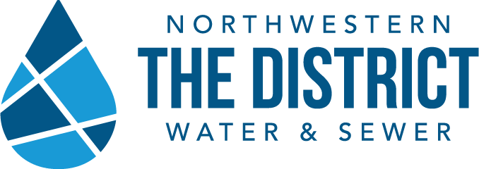

A Message from The Northwestern Water & Sewer District
Water Pressure & Your Home
The Northwestern Water and Sewer District receives questions regarding high pressure water in some areas in Middleton Township, including the Hull Prairie Subdivision and Saddlebrook.
The water pressure in this area runs between 75 PSI – 80 PSI (pounds per square inch). There is no maximum pressure limit for a public water system.
This is nothing new to the area, the pressure has always run between 75 PSI – 80 PSI due to the proximity of the Bowling Green Water Treatment plant.
As a water provider, it is our duty to provide residential and commercial water service and ensure water service for fire protection.
While we have investigated possible countermeasures, we have concluded that any measure we install would impair fire safety devices. The District has the responsibility to maintain both residential and fire safety water service. The Middleton Township Fire Department supports the findings of our investigation.
What should you do?
As a homeowner, you are responsible for plumbing from the curb to inside your home. To protect your plumbing we recommend you check to see if you have these two devices. Click on the links for video’s explaining these devices.
- An Expansion Tank
- Working pressure relief valve on your hot water tank.
The District is bringing up this issue because a few customers have concerns regarding damaged internal plumbing, such as hot water tanks. While The District is not responsible for your household plumbing, we advise that if you do not have these devices, you investigate having them installed. We recommend a professional licensed plumber. Again, this is not a requirement or mandate, this letter is intended to create awareness for those not familiar with water systems and plumbing.
If you have additional questions, please let us know.
Theresa Pollick
Public Information Officer
Northwestern Water & Sewer District
419-354-9090 EX 193

